Rolling correlation: AUDUSD and NZDUSD
Method 05 / daily log returns / windows 20, 60, 100 / Short watchlist

Study setup
Logical pair: AUDUSD , NZDUSD
Broker symbols: AUDUSD_i , NZDUSD_i
Tier: Short watchlist (short_watchlist)
Snapshot: 2026-11-03_majors_alpari_D1
Timeframe: D1
Matched return window: 1999-01-05 to 2026-11-02 (UTC bar dates)
Matched return count (rows before rolling): 7202
Dropped unfinished last bar dated 2026-11-03 UTC after a tick-volume check against the prior complete day.
Rolling windows W: 20, 60, 100 trading days
Live-shaped n for each score: n = W (not the full history length)
Complete matched rows (CSV): AUDUSD-NZDUSD_Rolling_D1.csv
Complete matched rows (HTML): AUDUSD-NZDUSD_Rolling_D1_data.html

Method carried forward
Rolling Pearson r is computed on matched daily log returns of close, ln(close_t / close_t-1), in the broker quote direction. Quotes are not inverted. For each day t with a full window, r_W uses the last W matched return pairs ending at t. That live-shaped sample size is W (20, 60, or 100), not the full multi-year history. The first W-1 days have no score. r is symmetric under swap of the two symbols. A high |r| in one window does not prove cause, lead-lag, or a trading signal. Short windows are noisier; long windows are slower to reflect a break.
How to read a live day: after both daily candles close, the newest r_20 uses the last 20 matched log returns, r_60 the last 60, and r_100 the last 100. Compare those three to each other and to the full-sample baseline below. A break is when the short window moves far from the baseline or flips sign while the baseline was meaningful.

Full-sample Pearson baseline (method 01 v001)
Copied full-sample Pearson r for AUDUSD-NZDUSD: 0.828722. This is a historical average link, not the live state.

Rolling results
W | latest_r | mean | median | min | max | std | pct_|r|>=0.4 | pct_|r|>=0.7 | n_roll
20 | 0.263046 | 0.806653 | 0.833636 | 0.062828 | 0.985605 | 0.125776 | 98.89 | 84.02 | 7183
60 | 0.606659 | 0.809122 | 0.824552 | 0.381434 | 0.955757 | 0.097526 | 99.92 | 87.01 | 7143
100 | 0.705993 | 0.811457 | 0.828763 | 0.450975 | 0.946013 | 0.090679 | 100 | 88.17 | 7103
n_roll is the number of days that had a complete window. pct_|r|>=0.4 and pct_|r|>=0.7 are the share of those days where the absolute rolling correlation cleared the threshold.

Conclusion
For AUDUSD and NZDUSD, full-sample Pearson baseline r=0.8287. Latest rolling scores: r_20=0.2630, r_60=0.6067, r_100=0.7060. Stability: moderate window-to-window variation. Agreement with baseline: r_20=0.263 far from baseline (0.57); r_60=0.607 near baseline; r_100=0.706 near baseline. Tier line: watch — short window has pulled away from the full-sample baseline; treat the link as unstable until windows re-align. This is a monitoring summary, not a trade signal.

What to look at in this file next time
1) Latest r_20 vs r_60 vs r_100 in the results table. 2) Whether short-window latest has the same sign as the baseline. 3) The rolling chart for stretches where |r| collapsed. 4) The CSV if you need a different chart later.

Charts
Rolling Pearson r (20 / 60 / 100)
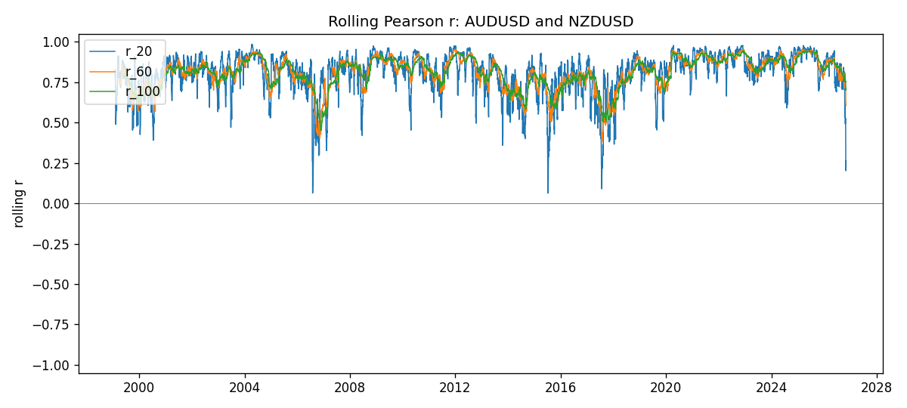
Daily closes

Daily log returns
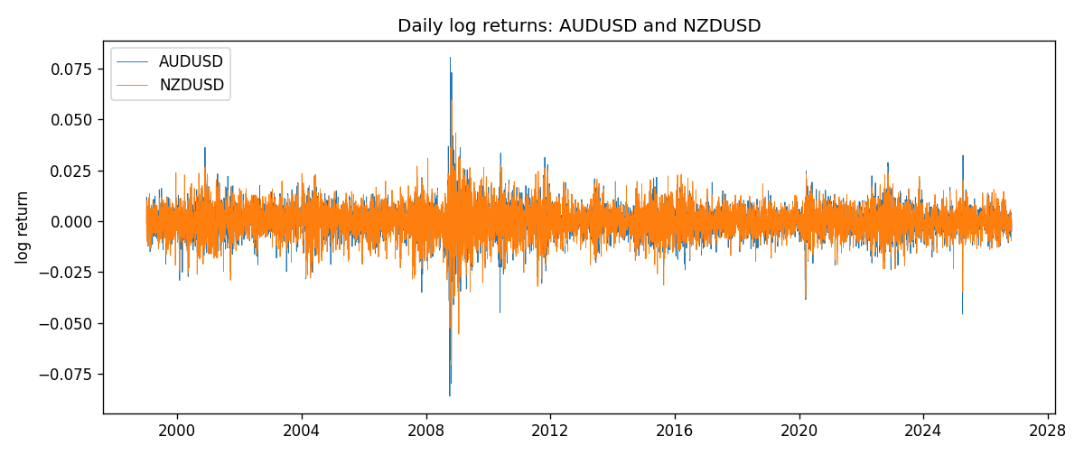

Data report
Every matched row with r_20, r_60, and r_100 is in the sibling CSV and HTML. This Word section holds column summaries and the first and last 15 rows of the rolling table.
Columns: time, AUDUSD_close, NZDUSD_close, AUDUSD_tick_volume, NZDUSD_tick_volume, AUDUSD_log_return, NZDUSD_log_return, r_20, r_60, r_100
Column summaries
column | count | mean | std | min | 25% | 50% | 75% | max
AUDUSD_close | 7202 | 0.751958 | 0.135285 | 0.4786 | 0.661192 | 0.731645 | 0.809065 | 1.10169
NZDUSD_close | 7202 | 0.656278 | 0.10825 | 0.3907 | 0.59141 | 0.668305 | 0.724917 | 0.8822
AUDUSD_tick_volume | 7202 | 77337.3 | 138129 | 109 | 5435.5 | 43320 | 71312.2 | 1.23462e+06
NZDUSD_tick_volume | 7202 | 68561.9 | 123036 | 17 | 5505.5 | 33822 | 58470.2 | 1.12768e+06
AUDUSD_log_return | 7202 | 2.237e-05 | 0.00754318 | -0.0860252 | -0.00386318 | 0.00028132 | 0.00415217 | 0.0806166
NZDUSD_log_return | 7202 | 5.13e-06 | 0.00764596 | -0.0702743 | -0.00426304 | 0.00021271 | 0.00457975 | 0.0596684
r_20 | 7183 | 0.806653 | 0.125776 | 0.0628275 | 0.754026 | 0.833636 | 0.896339 | 0.985605
r_60 | 7143 | 0.809122 | 0.0975258 | 0.381434 | 0.755825 | 0.824552 | 0.88209 | 0.955757
r_100 | 7103 | 0.811457 | 0.0906789 | 0.450975 | 0.763461 | 0.828763 | 0.882634 | 0.946013
First 15 matched rows
time | AUDUSD_close | NZDUSD_close | AUDUSD_log_return | NZDUSD_log_return | r_20 | r_60 | r_100
1999-01-05 | 0.6215 | 0.5372 | -0.000804182 | -0.00185977
1999-01-06 | 0.6289 | 0.5383 | 0.0118364 | 0.00204556
1999-01-07 | 0.6345 | 0.5417 | 0.00886503 | 0.00629632
1999-01-08 | 0.6347 | 0.5414 | 0.000315159 | -0.000553965
1999-01-11 | 0.6393 | 0.547 | 0.00722138 | 0.0102904
1999-01-12 | 0.6362 | 0.5441 | -0.00486085 | -0.00531575
1999-01-13 | 0.6312 | 0.5387 | -0.00789021 | -0.00997422
1999-01-14 | 0.6295 | 0.5386 | -0.00269692 | -0.000185649
1999-01-15 | 0.634 | 0.5382 | 0.0071231 | -0.000742942
1999-01-18 | 0.6346 | 0.5372 | 0.000945925 | -0.00185977
1999-01-19 | 0.6392 | 0.5382 | 0.00722252 | 0.00185977
1999-01-20 | 0.64 | 0.5404 | 0.00125078 | 0.00407937
1999-01-21 | 0.6405 | 0.5426 | 0.000780945 | 0.00406279
1999-01-22 | 0.6327 | 0.5361 | -0.0122527 | -0.0120517
1999-01-25 | 0.6302 | 0.5342 | -0.00395915 | -0.00355041
Last 15 matched rows
time | AUDUSD_close | NZDUSD_close | AUDUSD_log_return | NZDUSD_log_return | r_20 | r_60 | r_100
2026-10-13 | 0.69821 | 0.56127 | 0.00350077 | 0.00473262 | 0.809345 | 0.79269 | 0.760864
2026-10-14 | 0.69715 | 0.55918 | -0.00151932 | -0.00373065 | 0.782691 | 0.793297 | 0.804544
2026-10-15 | 0.69191 | 0.56185 | -0.00754471 | 0.00476349 | 0.530827 | 0.719834 | 0.767429
2026-10-16 | 0.69426 | 0.56509 | 0.00339064 | 0.0057501 | 0.594785 | 0.722361 | 0.771122
2026-10-19 | 0.6978 | 0.56616 | 0.005086 | 0.00189171 | 0.602349 | 0.725748 | 0.772121
2026-10-20 | 0.70022 | 0.56827 | 0.00346204 | 0.00371993 | 0.628733 | 0.738368 | 0.777637
2026-10-21 | 0.70275 | 0.57003 | 0.00360664 | 0.00309233 | 0.505064 | 0.750002 | 0.771417
2026-10-22 | 0.70186 | 0.56815 | -0.00126726 | -0.00330352 | 0.492026 | 0.711408 | 0.771263
2026-10-23 | 0.70353 | 0.56991 | 0.00237657 | 0.00309299 | 0.506855 | 0.712589 | 0.752808
2026-10-26 | 0.70128 | 0.56826 | -0.00320328 | -0.00289939 | 0.527592 | 0.711615 | 0.754691
2026-10-27 | 0.70245 | 0.56811 | 0.00166699 | -0.000263999 | 0.485074 | 0.703277 | 0.758498
2026-10-28 | 0.70533 | 0.56261 | 0.00409155 | -0.00972839 | 0.27393 | 0.632619 | 0.715651
2026-10-29 | 0.70245 | 0.56296 | -0.00409155 | 0.000621907 | 0.213938 | 0.617168 | 0.700983
2026-10-30 | 0.70316 | 0.56307 | 0.00101024 | 0.000195377 | 0.201958 | 0.607638 | 0.701
2026-11-02 | 0.69971 | 0.56161 | -0.0049185 | -0.0025963 | 0.263046 | 0.606659 | 0.705993

